PENGUINS SIZE DATA ANALYSIS PROJECT
Excel Project
Diana Banuelos-Ramirez
June 2026

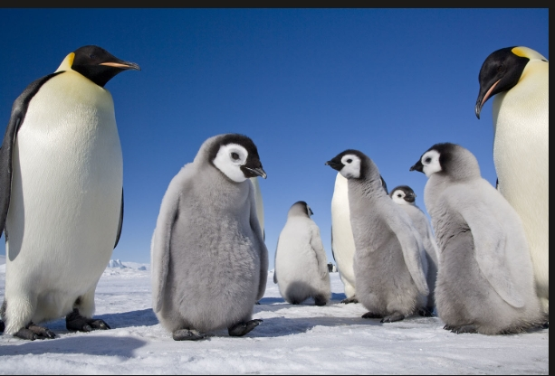

TABLE OF CONTENTS

Dataset 3
DATA EXPLORATION 3
DATA PREPARATION 4
PRELIMINARY ANALYSIS 5
ANALYSIS 6-7
EXECUTIVE SUMMARY 8
CONCLUSIONS 8

Dataset
The dataset used for this project is the penguins_size dataset. It contains information about penguin species, including measurements such as culmen length, culmen depth, flipper length, body mass, sex, and island location. The dataset is used to explore and summarize penguin characteristics.

DATA EXPLORATION

 | species | island | culmen_length_mm | culmen_depth_mm | flipper_length_mm | body_mass_g | sex
COUNT, cells with numbers |  |  | 342 | 342 | 342 | 342
COUNTA, cells not empty |  | 345 | 345 | 345 | 345 | 345 | 345
COUNTIF, cells with "NA" |  | 0 | 2 | 2 | 2 | 2 | 10
AVERAGE, ignores "NA" |  |  | 43.92 | 17.15 | 200.92 | 4201.75
STDEV, ignores "NA" |  |  | 5.46 | 1.97 | 14.06 | 801.95
VAR |  |  | 29.81 | 3.90 | 197.73 | 643131.08
MIN |  |  | 32.10 | 13.10 | 172.00 | 2700.00
MAX |  |  | 59.60 | 21.50 | 231.00 | 6300.00
Data type (Text, Integer or Decimal) |  | Text | Number | Number | Number | Number | Text
Numerical or Categorical |  | Categorical | Numerical | Numerical | Numerical | Numerical | Numerical
Continuous or Discrete |  | Discrete | Continuous | Continuous | Continuous | Continuous | Discrete
MODE, numerical fields only |  | N/A | 41.1 | 17 | 190 | 3800 | N/A

The correlation table shows relationships between penguin measurements. Flipper length and body mass have a strong positive relationship, while culmen depth has a negative relationship with some other measurements.

DATA PREPARATION
 | species_code | island_code | culmen_length_mm | culmen_depth_mm | flipper_length_mm | body_mass_g | sex_code
species_code | 1 | -0.009175517124 | 0.7305476686 | -0.7403460875 | 0.850736784 | 0.7504335824 | 0.01096360593
island_code | -0.009175517124 | 1 | 0.2120382922 | 0.1896359746 | -0.1627386373 | -0.2019664467 | 0.005834052857
culmen_length_mm | 0.7305476686 | 0.2120382922 | 1 | -0.2286256359 | 0.6530956387 | 0.5894511102 | 0.3440777822
culmen_depth_mm | -0.7403460875 | 0.1896359746 | -0.2286256359 | 1 | -0.5777916963 | -0.4720156602 | 0.3726732882
flipper_length_mm | 0.850736784 | -0.1627386373 | 0.6530956387 | -0.5777916963 | 1 | 0.8729788986 | 0.2551688758
body_mass_g | 0.7504335824 | -0.2019664467 | 0.5894511102 | -0.4720156602 | 0.8729788986 | 1 | 0.2551688758
sex_code | 0.01096360593 | 0.005834052857 | 0.3440777822 | 0.3726732882 | 0.2551688758 | 0.4249869909 | 1

Most penguin measurements were clustered within normal range, with only a few possible outliers visible in the flipper length data. The flipper length variable showed a wider spread compared to culmen depth. I would like to further analyze the relationship between flipper length and body mass.

PRELIMINARY ANALYSIS

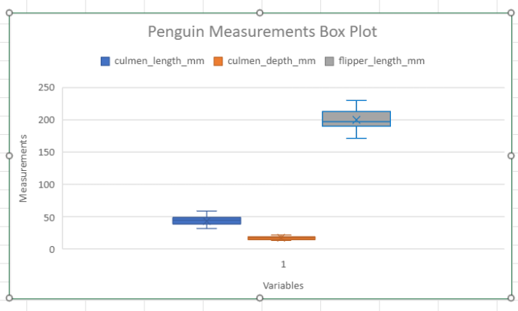
The box plot was used to compare the distribution of penguin measurements. The flipper length variable showed the greatest spread, while culmen depth showed less variation. The box plot also helped identify potential outliers and provided a visual summary of the range and distribution of the data. This preliminary analysis suggests that flipper length may be an important variable for further investigation.

ANALYSIS

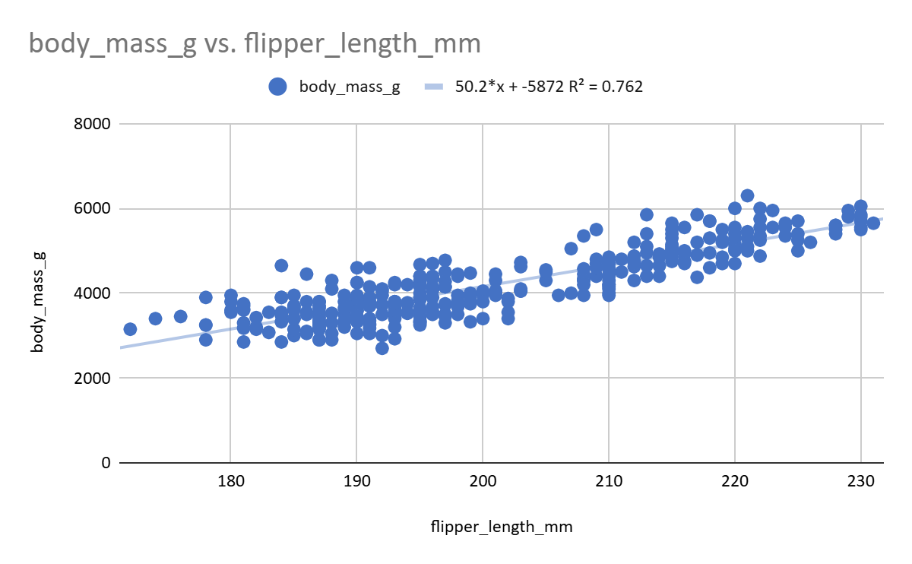
A scatter plot was created comparing body_mass_g and flipper_length_mm. The plot shows a positive linear relationship between the two variables. As flipper length increases, body mass also tends to increase.
The coefficient of determination (R² = 0.762) indicates that approximately 76.2% of the variation in body mass can be explained by flipper length. This suggests a strong relationship between these variables. The scatter plot shows a strong positive relationship between flipper length and body mass. Penguins with longer flippers generally have higher body mass values .The trendline and R² value suggest that flipper length is a useful predictor of body mass in this sample of penguins. I would further analyze the relationship between culmen length and body mass to compare how strongly those variables are connected.

Analysis
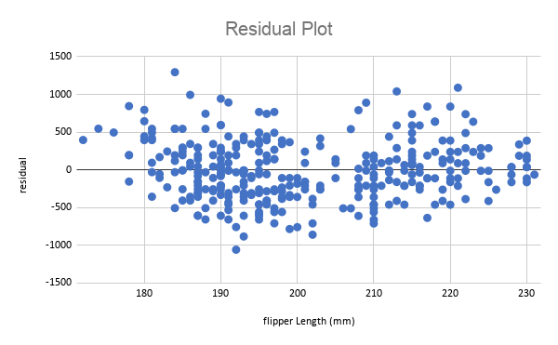
The residual plot was used to evaluate the fit of the linear regression model. The residuals are distributed above and below zero without a strong systematic pattern, indicating that a linear model provides a reasonable fit for the relationship between flipper length and body mass. Some variation remains, suggesting that additional factors may influence body mass.

Metric | Value
RMSE | 392.16

The Root Mean Squared Error (RMSE) was 392.16 grams. This indicates that the model's predictions differ from the actual body mass values by approximately 392 grams on average.

EXECUTIVE SUMMARY

This project improved my experience using Excel for data analysis, organization, and visualization. The dataset analyzed was the penguins_size dataset, which included penguin species information and body measurements such as culmen length, flipper length, and body mass. Through data exploration and preparation, I learned how to summarize data, identify correlations, and visualize relationships between variables. I used charts, box plots, and scatter plots to model the data and better understand measurement patterns among penguins. The analysis showed that flipper length and body mass were the two most strongly correlated variables, indicating that penguins with longer flippers generally had greater body mass. Overall, this project strengthened my understanding of Excel functions, data preparation, modeling, and data visualization techniques.

CONCLUSIONS

The calculated RMSE measures the prediction error of the model. A lower RMSE indicates that the model predictions are closer to the actual values, suggesting a better fit for the data.
The RMSE for this model was 393.34. This means that the predicted body mass values differ from the actual body mass values by about 393 grams on average. Considering that penguin body mass ranges from approximately 2700 to 6300 grams, the model provides a reasonably accurate prediction of body mass based on flipper length.
The dataset showed strong relationships between several penguin measurements, especially between flipper length and body mass. Data preparation and correlation analysis helped identify patterns and relationships between variables. The scatter plot and trendline demonstrated a positive relationship between flipper length and body mass, making it useful for predictive analysis.
This project helped me learn how to import, organize, clean, and analyze data using Excel. I also learned how to create tables, charts, and correlation analyses to better understand relationships within a dataset. Additionally, I learned how data visualization can help identify trends and support modeling decisions.

